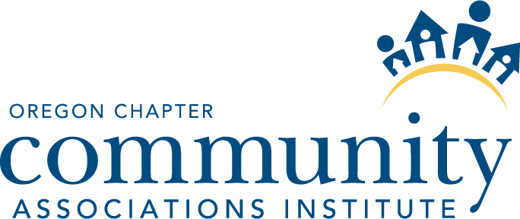

DATE: November 13, 2015
TIME: 10:30 am
LOCATION: Multnomah Athletic Club

Board Members Present: Jed Spera, Kathleen Profitt, Andrea Klopfenstein, Sara Eanni, Brad Finson, Connie Plowman, Angela Shinn, and Jason Grosz.

Also in attendance: Greg Coxey, Barb Casey, Laura McDermott.

- Call to Order
AGREED: President Jed Spera called the meeting to order at 10:37 AM.
- Approval of Minutes from October 10, 2015
AGREED: Director Angela Shinn moved to approve the October 10, 2015 minutes with an edit to reflect that she was also in attendance at the meeting, and to correct the spelling of Kathleen’s last name. The motion was seconded and carried without objection.
- CED Report – Laura McDermott
Laura McDermott stated she had attended the CED Retreat. There was also a discussion regarding how the Gala went.
- New Business
  - Nomination of Barb Casey as Ex Officio Officer of the Board
AGREED: Director Jason Grosz moved to nominate Barb Casey as past president to fill the Ex Officio Board member role. The motion was seconded and carried without objection.
  - Election of Officers
    - President-Elect
There was a vote for President-Elect resulting in a tie.
AGREED: Director Sara Eanni was elected to serve as President-Elect.
AGREED: Angela Shinn was unanimously elected to serve as Vice-President.
    - Secretary
AGREED: Kathleen Profitt was elected to serve as Secretary.
    - Treasurer
AGREED: Andrea Klopfenstein was elected to serve as Treasurer.
  - Selection of Committee Liaisons
AGREED: Committee Appointments were made by Jed Spera as follows:
Angela Shinn – CA Day
Jason Grosz – Education
Sara Eanni – Marketing
Brad Finson – Membership
Andrea Klopfenstein – Finance
Kathleen Profitt – Awards
Connie Plowman – CAVL Task Force
- Next Meeting Date
AGREED: The next meeting date was set to be held on December 11, 2015, at 2:00 PM. The tentative meeting location was set to be College Housing Northwest.
- Adjournment
There being no further business, the meeting was adjourned at 11:30 AM.

